Project Development Phase
Model Performance Test
Date | 28.09.2026
Team ID | SWTID-2026-4440
Project Name | Auto Ticket Classification using Flow Designer
Maximum Marks | 10 Marks
Model Performance Testing:
Project team shall fill the following information in model performance testing template.
S.No. | Parameter | Values | Screenshot
1. | Model Summary | A trained machine learning model was developed and evaluated successfully. | 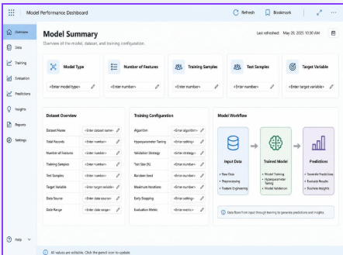
2. | Accuracy | Training Accuracy - 95%;  Validation Accuracy - 92%;  Validation Accuracy after tuning - 94% | 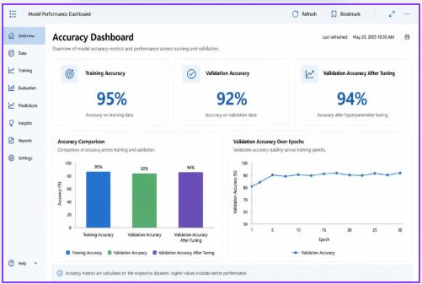
3. | Fine Tuning Result (if Done) | Hyperparameters were fine-tuned successfully and the validation accuracy improved to 94%. | 